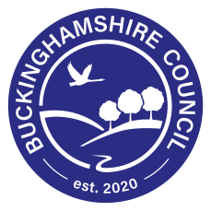
What you can expect from us:
- Free information and advice on courses, qualifications and help with cost where applicable

- Every effort made to contact you if your class is cancelled

- Health and safety information

- All comments and complaints listened to and resolved quickly

- Teaching by experienced and trained staff

- Support in all areas of your learning

- Learning assessed regularly and feedback provided on how you can improve

- Advice on what to do next and access to careers guidance where appropriate

- A safe and secure environment with all safeguarding issues dealt with by our Safeguarding Officer or a member of the Safeguarding team

We ask you to:
- Commit to your course and your learning

- Attend every class, arrive on time and tell us if you cannot come to a session

- Show respect and care for equipment, buildings and other people and their property. This includes not uploading any images or videos taken in class to the internet

- Support the completion of paperwork and ensure that you sign your Learning Agreement in order for us to claim funding and keep classes open

- Pay any fees which are due

- Tell us as soon as you can if you think you may need additional support with your learning due to a disability or learning difficulty. Please speak to your tutor or contact our Learning Support Officer- Christine Jakeman on 07825052627 or email aldisability@buckinghamshire.gov.uk

